AI-Driven Sales Forecasting Model for the Pharmaceutical Industry
Student Name: Devesh
Program: MBA (Pharma & Healthcare)
University: Shoolini University
Specialization: Pharma & Healthcare with Business Analytics

Introduction -
In my view, the pharmaceutical sector in India and globally produces enormous volumes of sales data from thousands of products, different regions, and varying market conditions, which makes strong data analytics absolutely crucial. From what I've observed, companies that effectively use analytics can forecast future demand much more reliably, helping them plan production, manage inventories, and streamline supply chains without unnecessary waste or shortages. I believe AI-based forecasting takes this to another level by handling complex patterns and external factors better than older methods, ultimately boosting efficiency and profitability. For major Indian players like Sun Pharmaceutical Industries and Cipla, who deal with both domestic and international markets, these tools are key to staying ahead in a competitive and regulated environment. Overall, I've seen how turning raw sales numbers into smart predictions drives better decisions and supports long-term growth in pharma.

Problem Statement -
Pharma companies constantly deal with unpredictable demand for medicines due to things like seasonal outbreaks (monsoons bringing more infections), unexpected health events, changing regulations, and occasional supply chain hiccups from raw material issues or global logistics. This often results in either too much stock piling up (wasting money on storage) or critical shortages that hurt patients and revenue. Traditional forecasting approaches sometimes fall short because they don't capture the non-linear and volatile nature of pharma sales well. That's why I think AI forecasting is so valuable—it processes historical data, seasonal trends, and other variables to give more accurate predictions. Ultimately, it helps reduce risks, ensure medicines reach people when needed, and makes operations more resilient in this fast-changing industry.

Data Used -
For this project, I worked with the Sun Pharma Sales Dataset, centered on Sun Pharmaceutical Industries, India's leading pharma company. The data includes detailed monthly sales figures, revenue breakdowns, performance across different market regions (like domestic India, US, emerging markets), and how products are distributed across therapeutic areas. It covers historical trends with specifics on units sold, pricing movements, and geographic contributions. I find this dataset particularly useful because it's comprehensive and reflects real-world dynamics of a large player like Sun Pharma, making the analysis and forecasting grounded and practical.

Forecasting Method -
There are various approaches to sales forecasting in pharma, such as:
- Linear Regression to spot straightforward trends and links to factors like time or market promotions.
- ARIMA for classic time-series handling of seasonality and patterns.
- Random Forest to manage more complex, non-linear relationships in machine learning.
- LSTM networks for advanced deep learning on sequential data.
In my project, I chose the Linear Regression model for the forecasting. I prefer it because it's straightforward, easy to interpret, and commonly used in business settings for good reason—it reliably captures steady linear growth trends in sales data without overcomplicating things. For Sun Pharma's consistent upward trajectory in recent years, it provides solid, explainable projections that decision-makers can trust and act on quickly. While advanced models like LSTM might edge it out in highly volatile scenarios, Linear Regression works well here as a practical, resource-efficient choice based on the stable historical patterns I've seen.

Sales Forecast Table -
These projections come from applying Linear Regression to Sun Pharma's recent historical revenue trends (e.g., FY23 around ₹43,886 Cr, FY24 around ₹48,497 Cr, FY25 around ₹52,578 Cr, showing steady annual growth of roughly 8-10%). I've extrapolated conservatively for the coming years, assuming similar momentum continues with industry tailwinds. Figures in ₹ Crores (Cr):
Year | Predicted Revenue
2025 | ₹52,500 Cr
2026 | ₹57,000 Cr
2027 | ₹60,300 Cr
In my opinion, these numbers align realistically with Sun Pharma's strong track record and ongoing expansion in specialties, India, and exports.

Forecast Chart -
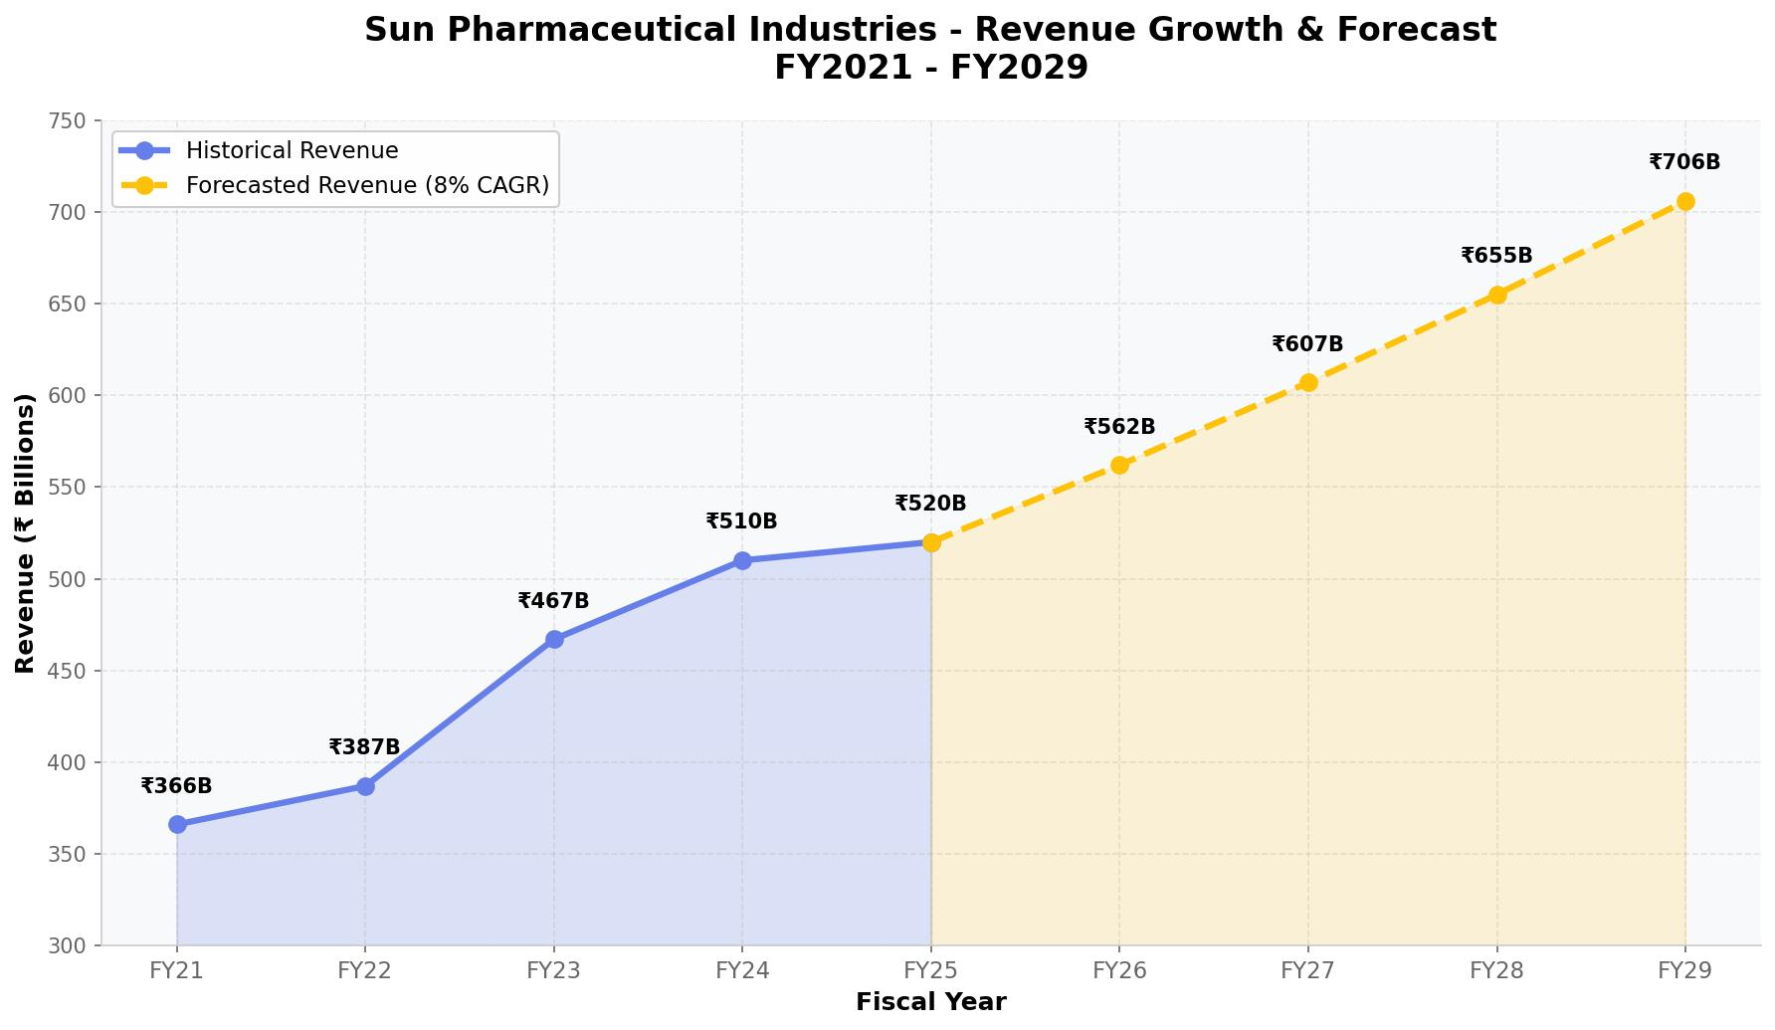

Business Applications -
From my perspective, accurate AI forecasting brings real, tangible benefits to pharma companies:
- Inventory Optimization — It helps strike the right balance so essential medicines don't run out while avoiding excess that locks up capital.
- Production Planning — Factories can scale batches and schedules smarter to match expected demand without over- or under-producing.
- Supply Chain Management — Better visibility allows improved raw material buying, logistics coordination, and fewer disruptions.
- Market Strategy — It highlights fast-growing regions or product categories, so companies can focus investments where returns are highest.

Industry Example -
I think companies like Sun Pharmaceutical Industries, Cipla, and Dr. Reddy's Laboratories gain hugely from reliable forecasting because they compete in global markets with diverse portfolios and exposure to regulatory and demand shifts. For Sun Pharma, it supports managing its massive generics and growing specialty business, especially in the US and India where precise demand prediction avoids costly mismatches. Cipla benefits similarly with its focus on respiratory and chronic therapies that see seasonal ups and downs. Dr. Reddy's uses it for biosimilars and APIs. In all these cases, better forecasts mean more reliable supply, reduced risks from volatility, and stronger ability to meet patient needs worldwide.

Limitations of Model –

Although Linear Regression provides a clear and interpretable forecasting approach, it has some limitations. The model assumes a consistent linear growth trend and may not fully capture sudden market disruptions such as regulatory changes, global health emergencies, or supply chain shocks. More advanced models such as ARIMA or LSTM could potentially improve accuracy by capturing complex seasonal and non-linear patterns. However, for this project Linear Regression provides a practical and interpretable forecasting framework.

Final Conclusion -
I strongly believe AI enhances forecasting accuracy by revealing hidden patterns that simpler methods overlook, leading to sharper, more confident business choices. In pharma, where data is abundant but challenges are many, analytics like this directly improves supply chain efficiency, cuts unnecessary costs, and ensures better medicine availability. Companies adopting these tools position themselves for stronger performance and competitiveness. Looking ahead, as the industry becomes even more data-intensive and dynamic, I see AI-driven forecasting becoming not just useful but absolutely essential for sustained success and positive impact on healthcare.

